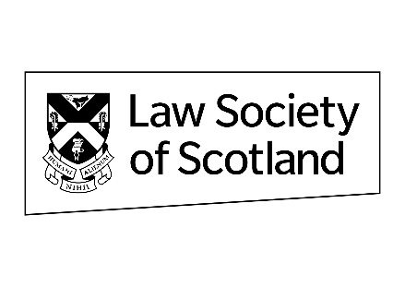
AGM 2023 – 29 June 2023
Proposed constitution amendment
Mutual Trading Status and Corporation Tax
The proposed amendment to the constitution below seeks to address a potential risk to the Law Society of Scotland’s mutual tax status, which is the basis on which the Society’s tax computations are prepared. The risk identified was in relation to the treatment of any surplus of the Society in the unlikely event of a winding up. The proposed changes to the constitution, drafted by Tax Counsel, are intended to address this risk, by specifying entitlement to share in any surplus on winding up, while clarifying that there would be no expected such distributions in the usual course of affairs.
Resolution Number 4 from the Council of the Law Society of Scotland to amend the Scheme under the Solicitors (Scotland) Act 1980 being the Constitution of the Society.
That with effect from 00.01 hours on 30 June 2023, the Constitution of the Law Society of Scotland is amended by the addition of the following clauses:
Distributions of any surplus
1(1) In the event that the Society ends a financial year with a surplus of funds, the Society shall not make any distribution of any such surplus to any person who is not a Member of the Society.
(2) For the purposes of this section, a “surplus” arises when the income of the Society in any financial year exceeds the sums expended by the Society in that financial year.
(3) Notwithstanding the terms of sub-clause (1), in the usual course of affairs, the Society would not expect to make any distribution of any kind of any surplus.
(4) If the Society is wound up or dissolved or otherwise brought to an end and if there remains, after the satisfaction of all its debts and liabilities, any property whatsoever in the ownership of the Society, such property shall be paid or distributed exclusively among the Dissolution Members and such distribution shall be in proportion to the contributions made by those Dissolution Members during the final five years of the Society’s existence.
(5) For the purposes of this section “Dissolution Members” means the Members of the Society at the date of the winding up or dissolution of the Society and all such Members of the Society who were such Members within five years of that date.
(6) Nothing in sub-section (4) shall prevent the Society from restructuring its legal form in any manner it should choose provided that, following any such restructuring, the Society continues to operate for the Members of the Society with the same or substantially similar objects.

