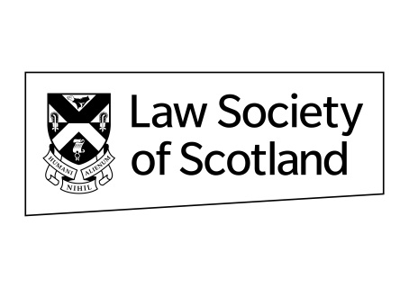

Nomination for Honorary Membership of the Law Society of Scotland in 2023
Deadline for submission: 12 noon 21 April 2023
PLEASE TYPE OR PRINT WHEN COMPLETING APPLICATION FORM
1. Name and address of solicitor nominated for Honorary membership of the Law Society of Scotland - Nominated solicitors must no longer be practising nor hold a practising certificate and solicitors cannot self-nominate.

Full Name
Firm (if applicable)
Home or Business address (if known)
Telephone No:
(if known)
Email: (if known)
2. Name and address of person proposing the nomination
Full Name
Firm (if applicable)
Home or Business address
Telephone No:

Email:
3. The criterion for the nomination of Honorary Membership in 2023 is “for outstanding service for the public good by a Scottish solicitor”. Nominees must no longer be practising nor hold a practising certificate. Please provide your reasons as to how your nominee has achieved this “mark” (Maximum 500 words)
Signature of proposer
Date
Completed nominations should be sent via email to James Ness jamesness@lawscot.org.uk

