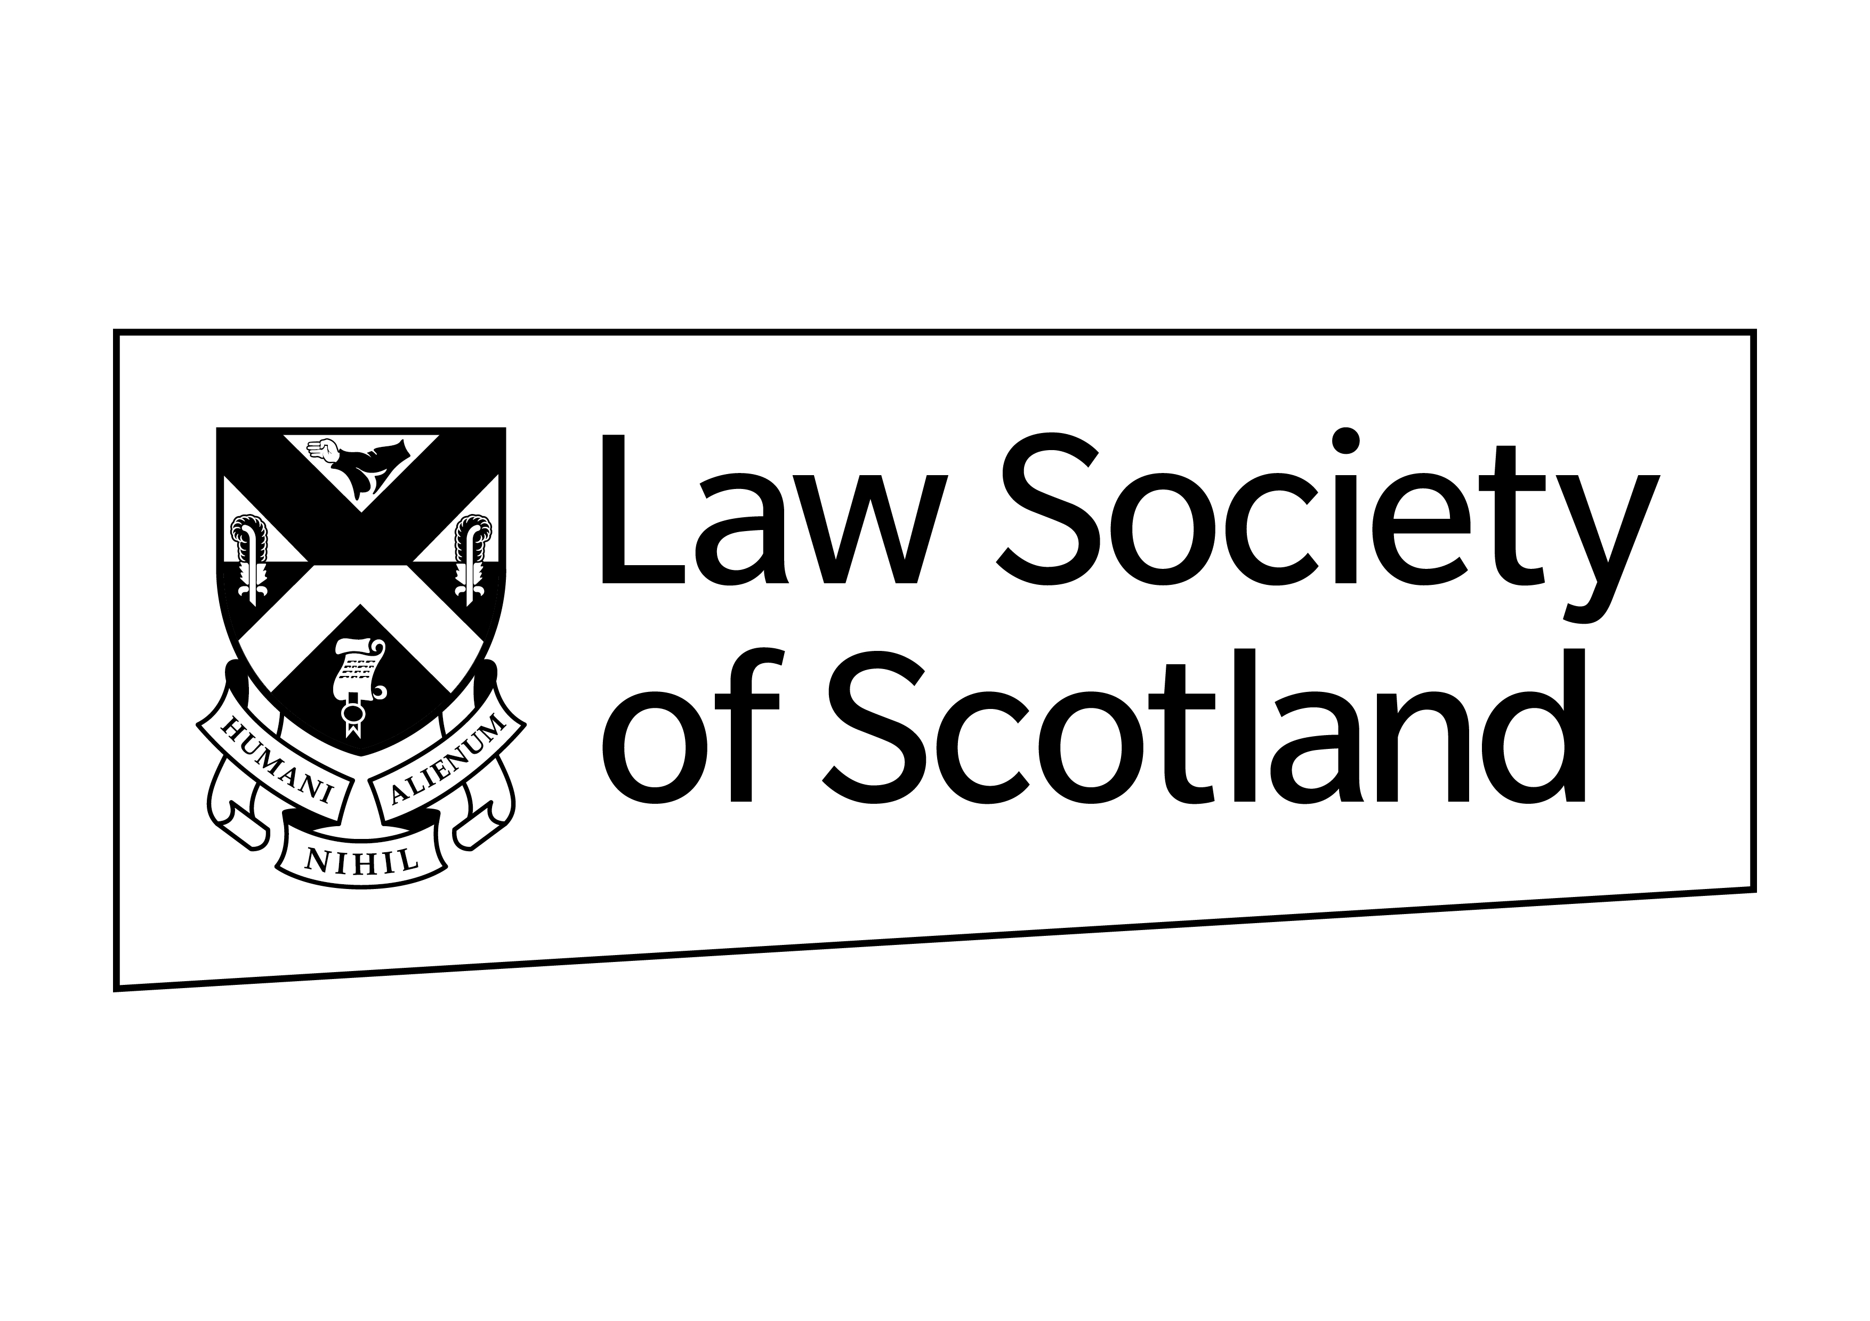

Innovation Cup - 2021

Prize: £1,500 (cash)
Deadline: 14 October 2021
PLEASE TYPE OR PRINT WHEN COMPLETING APPLICATION FORM
Part 1 General Information
Full Name
Home address
Telephone No:
Email:
Business address
Telephone No:
Email:
Which address would you prefer us to use for correspondence:

Home |  |  |  | Business

Part 2 Specific Information
Please identify your risk management “light bulb” idea to improve the systems, processes or controls within private practice firms. Entries should be between 500 – 2000 words and can include graphs, pictures or slides if appropriate. Please use additional paper as required.
Please return your completed form, by email, to paulmosson@lawscot.org.uk, Executive Director of Member Services and Engagement by 12 noon on 14 October 2021.
Signed
Date

